Student Guide: Creating Pivot Tables and Histograms in Excel
  - Using the GSS_2002_multitrait_labels Dataset

Learning Objectives
By the end of this lesson, students will be able to:
- Understand the structure of a real-world survey dataset
- Create pivot tables to summarize categorical data
- Interpret pivot table outputs
- Create and customize a histogram for numeric data
- Choose the correct visualization for different data types

Dataset Overview
File: GSS_2002_multitrait_labels.xlsx
Each row in this dataset represents one survey respondent.
Each column represents a survey variable, such as:
- happy – self-reported happiness (categorical)
- satjob – job satisfaction (categorical)
- Empathy – numeric summary score
- mntlhlth – number of poor mental health days
⚠️ Some cells contain non-response codes such as:
- .i: Inapplicable
- .d: Do not Know/Cannot Choose
Collected data values that won’t fit the type of analysis you want to do, in this case numeric, must be handled before analysis. There are multiple ways to do this. The filter option shared is just one approach. Manually sorting the values from highest to lowest can work too as another easy option.

Part 1: Preparing the Data

Step 1: Open the File
- Open Excel
- Open GSS_2002_multitrait_labels.xlsx
- Select the worksheet containing the main data
Visual Reference: Screenshot of Excel workbook with dataset visible

Step 2: Turn On Filters
- Click any cell inside the dataset
- Go to Data → Filter
✅ Small dropdown arrows should appear in each column header.
Visual Reference: Screenshot showing filter icons in column headers

Step 3: Filter Out Invalid Responses
For variables you will analyze:
- Click the filter arrow
- Uncheck:
- .i: Inapplicable
- .d: Do not Know/Cannot Choose
- Click OK
Visual Reference: Screenshot of filter menu with invalid values unchecked

Part 2: Creating a Pivot Table

What Is a Pivot Table?
A pivot table summarizes large datasets by counting, averaging, or grouping values.
We will start with a simple example.

Example 1: Count Respondents by Happiness Level

Step 4: Insert a Pivot Table
- Click inside the dataset
- Press Ctrl + A (select all data)
- Go to Insert → PivotTable
- Choose New Worksheet
- Click OK
Visual Reference: Screenshot of PivotTable dialog box
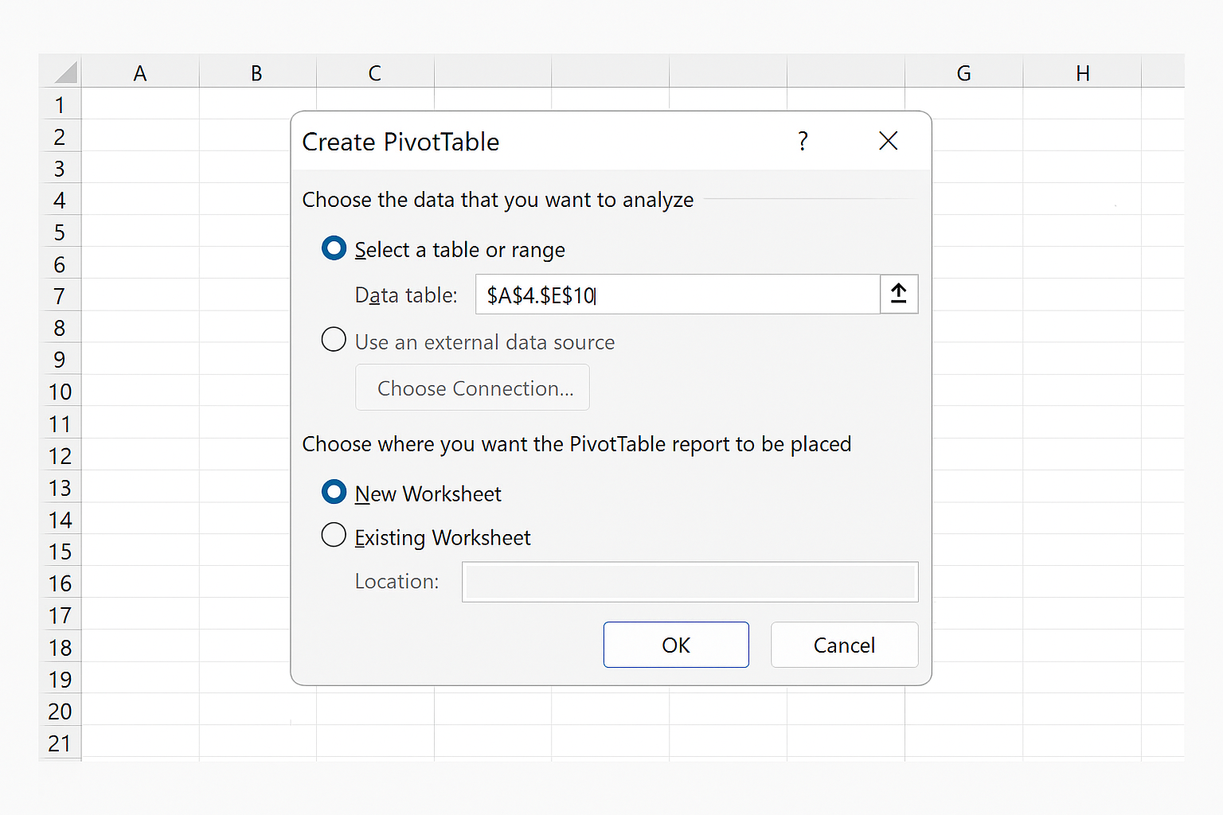

Step 5: Build the Pivot Table
In the PivotTable Fields panel:
- Drag happy → Rows
- Drag id_ → Values
Excel will default to Count of id_.
Visual Reference: Screenshot of PivotTable Fields panel with fields placed
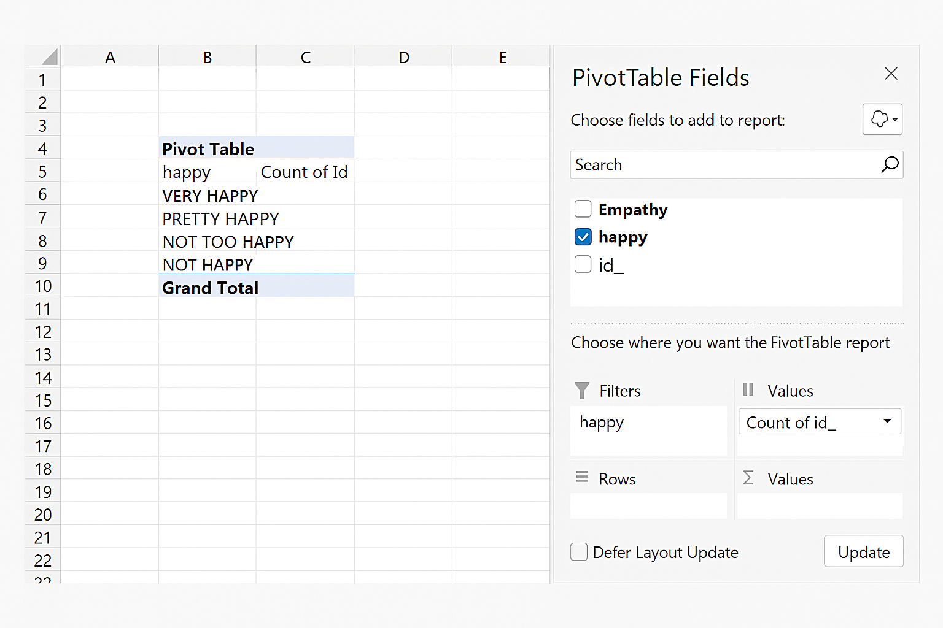

Step 6: Interpret the Pivot Table
You should now see:
- Rows = happiness categories
- Values = number of respondents in each category
This answers the question:
“How many people report each level of happiness?”
Visual Reference: Screenshot of PivotTable showing count by happiness category.

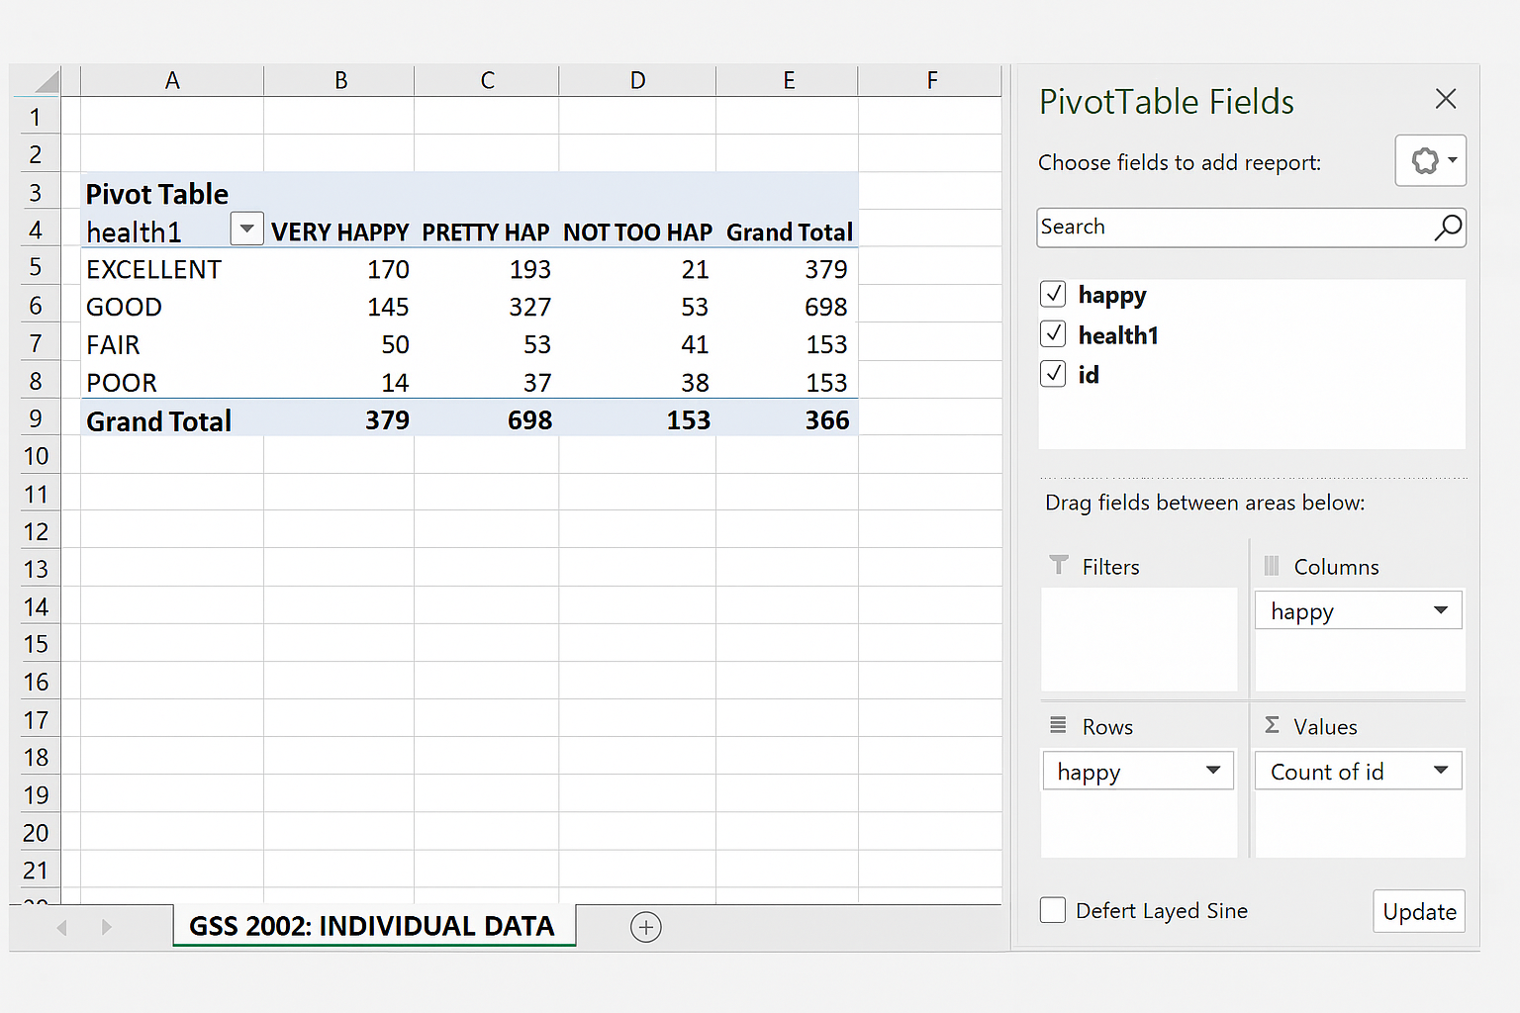

Part 3: Expanding Pivot Table Analysis

Example 2: Happiness by Job Satisfaction
- Keep happy in Rows
- Drag satjob → Columns
- Keep id_ → Values (Count)
This creates a two-way table showing how happiness varies by job satisfaction.
Visual Reference: Screenshot of PivotTable showing count by happiness and job satisfaction.

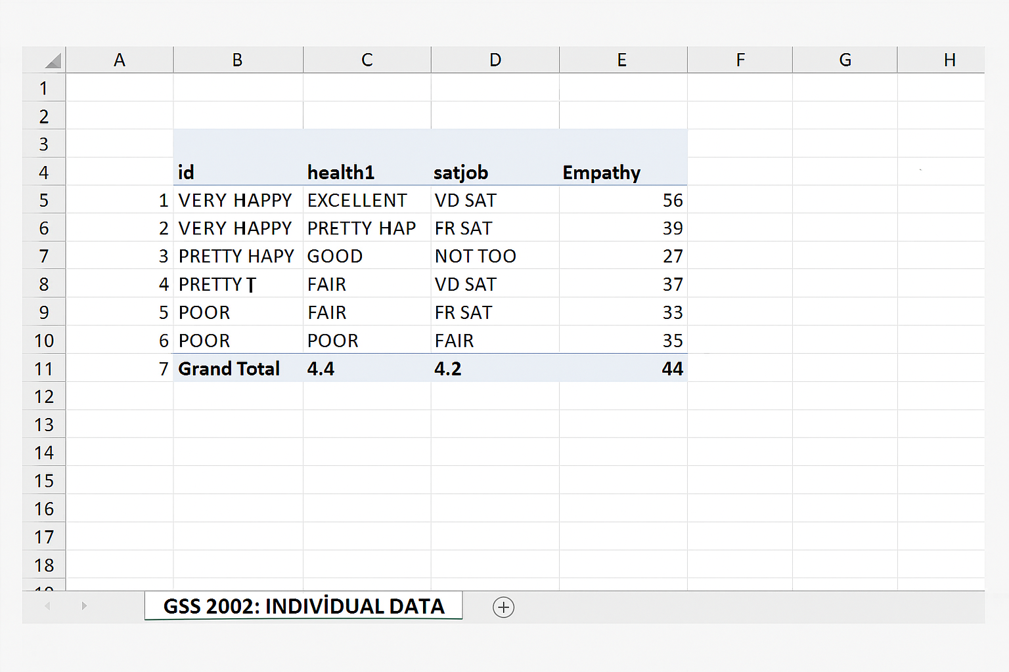

Part 4: Creating a Histogram

What Is a Histogram?
A histogram shows the distribution of a numeric variable by grouping values into ranges (bins).
⚠️ Histograms require numeric data only. Good candidates from this file:
- Empathy
- mntlhlth

Example: Distribution of Empathy Scores

Step 1: Select a Numeric Column/Prepare Data
- Select the entire numeric column (e.g., Empathy)
- Apply a filter if needed:
  - Remove any non-numeric entries
Visual Reference: Screenshot with Empathy column highlighted and filter to only numeric values
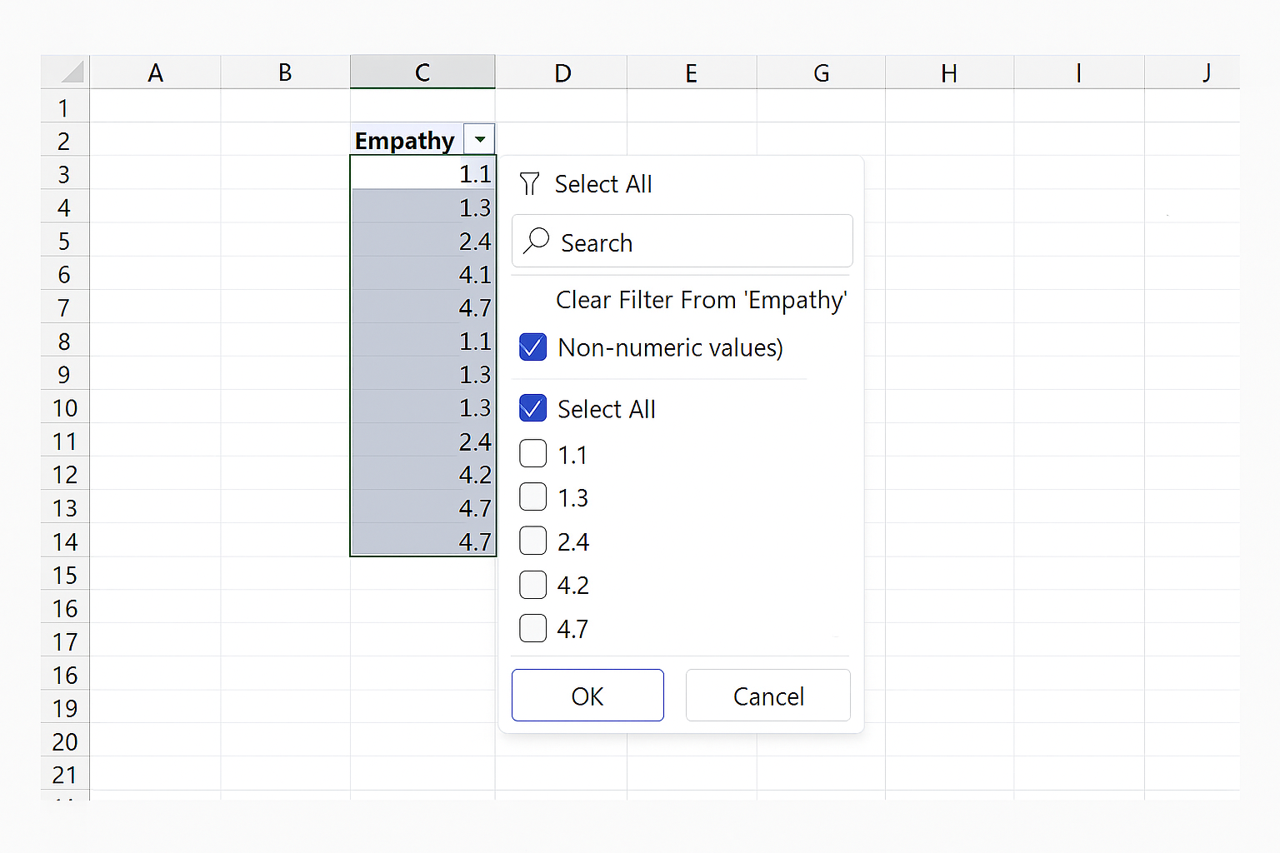

Step 2: Insert the Histogram
- With the numeric column selected:
  - Go to Insert
  - Click Insert Statistic Chart
  - Choose Histogram
- Excel automatically generates the histogram.

Visual Reference: Screenshot of Steps to Select a Histogram chart in Excel with Sample Histogram
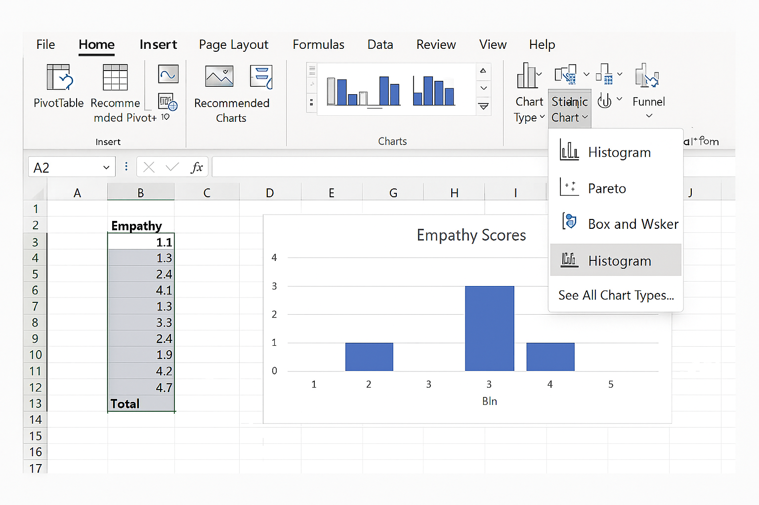

Step 3: Customize the Histogram
- Click the horizontal axis:
  - Right-click → Format Axis
- Adjust:
  - Bin width (e.g., 0.5 or 1)
  - Number of bins
- Add titles:
  - Chart Title: “Distribution of Empathy Scores”
  - X-Axis: “Empathy Score”
  - Y-Axis: “Number of Respondents”

Visual Reference: Screenshot of Histogram formatting panel open showing options
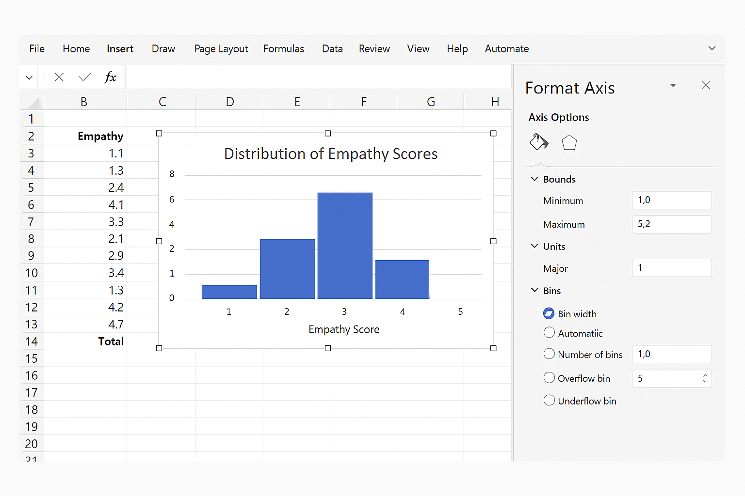

Part 5: Histogram Analysis
Visually, we can compare the initial bins Excel creates and the revision to the chart to help our analysis.
Left (Before adjustment)
- Histogram created with Excel’s default bin settings
- Fewer, wider bins
- More compressed view of the Empathy distribution
Right (After adjustment)
- Histogram after manual bin customization
- Smaller bin width / increased number of bins
- More detailed view of how Empathy scores are distributed across the 1–5 scale

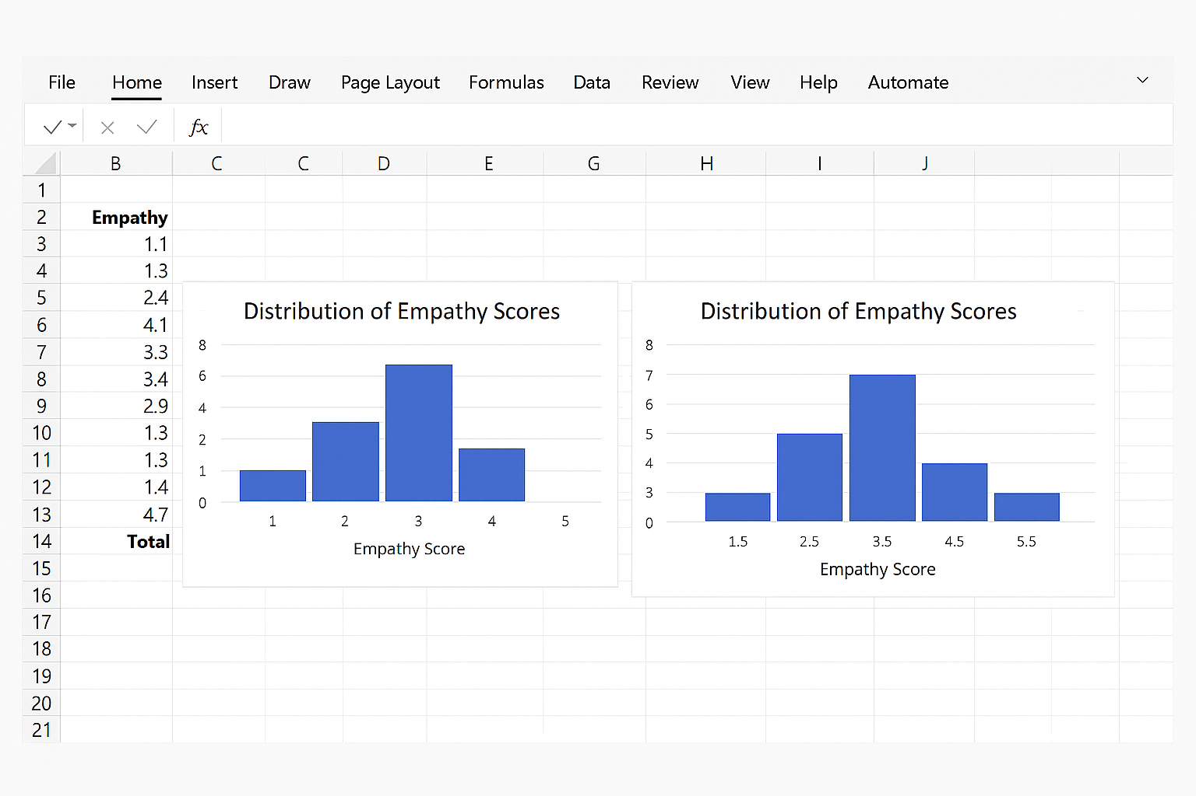

Key Takeaways for PivotTables and Histograms

Choosing the Right Tool
Data Type | Tool
Categorical | Pivot Table
Numeric | Histogram
Group comparisons | Pivot Table
Distribution shape | Histogram

Common Mistakes
- ❌ Including .i or .d values
- ❌ Using histograms for categories
- ❌ Missing chart labels
✅ Always clean data first and label visuals.

Reflection Questions
- What does the empathy distribution tell you?
- How does job satisfaction relate to happiness?
- Why is a histogram appropriate for empathy scores?

